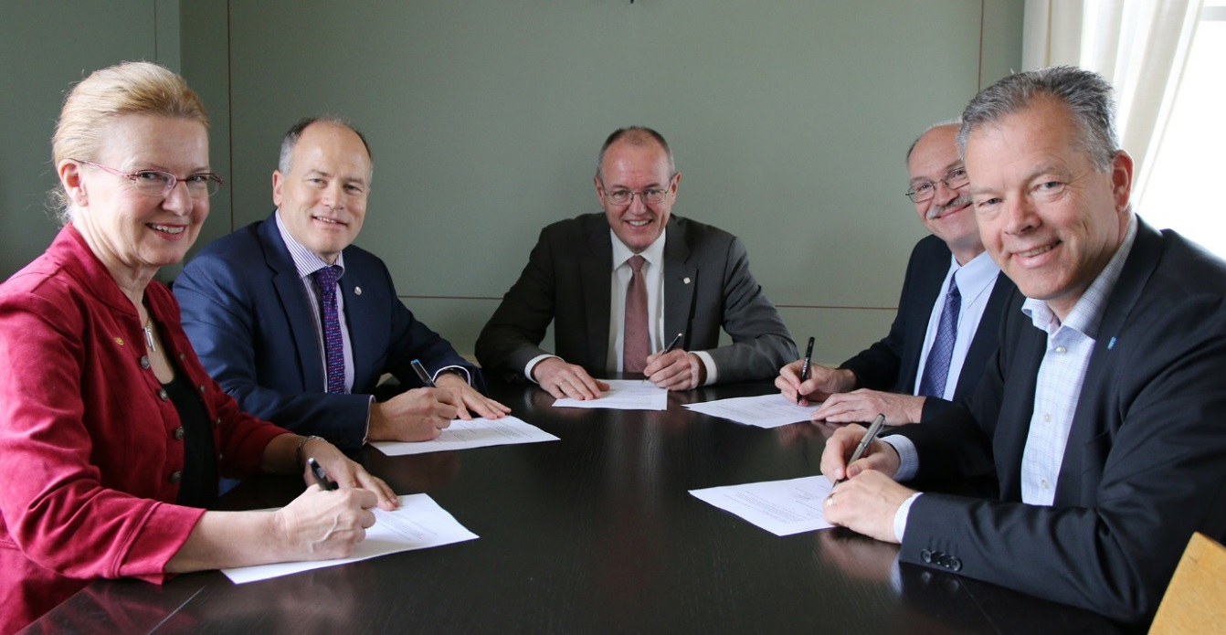
Signing the MoU on PhD collaboration at NTNU 4 June 2015, President Karin Markides (Chalmers), Dean Gary Marquis (Aalto), Rector Gunnar Bovim, President Anders Bjarklev (DTU) and President Peter Gudmundson. Photo: Idun Haugan (NTNU).

Nordic Five Tech (N5T): Status Report 2015 – 2016
It is the privilege of the Chair to present the annual report at the Rectors’ meeting. This year, we would like to highlight: communications and the follow-up of the “JMP 2.0” process, the self-assessment and strategy work, and the Nordic Summit on Universities for Impact.
The decision last year, to set up an N5T WG Communication has proven valuable. The first year, the WG gave priority to reshaping the websites of the joint master programmes. Last year, we also agreed to strengthen the jointness of the master programmes by trying out a new funding scheme and developing a joint admission procedure.
The self-assessment conducted the past year confirmed that the Joint Master Programmes and the QA Peer Evaluation are the most well-known results of Nordic Five Tech collaboration. Looking forward, the self-assessment also pointed to the potential in the research area. In this respect, the signing of the MoU on PhD collaboration in 2015 gave Nordic Five Tech a strategic foundation to build on. We welcome the new strategy and action plan, which has been developed by the N5T Committee and Secretariat, and hope that it will be instrumental in clarifying ambitions and priorities of the alliance in the short and long term.
From the start, it has been a Nordic Five Tech ambition to take a political role. The alliance is a recognized actor by the Nordic Council and through the “TU alliances speaking with one voice” in Brussels. With the Nordic Summit on Universities for Impact, Nordic Five Tech is also providing an arena for dialogue between major stakeholders in the Nordic innovation eco-system. It is an alliance filled with high aspirations that celebrates its 10th anniversary in 2016.
The succeeding report gives an update on Nordic Five Tech collaboration relating to education, research, innovation and industry relations, communication and organization.
NTNU, 26 May 2016

Education

1.1 Joint Master Programmes
The joint master programmes are important trademarks of the alliance as well as strategic platforms for wider academic collaboration. The past year, high priority has been given to the academic and administrative follow-up of the challenges identified in the “JMP 2.0” process and the programme reviews.
As a measure to strengthen quality assurance, all programmes will as of 2016, send a brief annual activity report to the N5T Committee. The report will also serve as documentation in institutional quality assurance systems. In the draft template for future consortium agreements, it is foreseen that programme reviews are conducted after graduation of the first class, while an external evaluation is conducted after graduation of the fourth class. The main attention should be given to joint elements, progression towards programme learning outcomes, and relevance to working life.
In the annual reports 2016, the programme coordinators describe a positive trend in applicant numbers and student arrivals in most programmes (see Annex 2). Once in the programme, most students finish their degree on time. Due to local necessity, there are a few track changes: in eNviro5Tech the Aalto-DTU track on Environmental Informatics is replaced by a new track on “Water Resource Management”, while in ISEE Aalto will replace Iceland as track-partner with Chalmers on “Heat and Power”. NMME and ISEE conduct student surveys, while Polymer will start this year. NMME and ISEE have run joint activities for a number of years, while Polymer and eNviro5Tech plan to start up. N5Team and SUT was not prolonged last year, and the last class is expected to graduate in 2017. Cold Climate Engineering had 14 applicants and 11 admitted students at the first intake. A video with potential employers has been made to promote the new programme.
To facilitate joint student activities, strengthen student satisfaction, and stimulate contact between the departments involved, an institutional funding scheme was set up as a trial case for the academic year 2015-16. The university hosting the joint activity should cover direct expenses relating to student travel and accommodation of up to 10 000 Euros. Chalmers hosted the NMME welcome weekend 2015, while Aalto hosted the ISEE winter school 2016.
Several administrative measures have been taken in support of the programmes. The N5T WG Communication has prioritized the development of programme websites based on the principle that potential students shall find complete information about the programme on the host university website and necessary admissions information at the websites of the partner universities. The N5T WG JMP Administrators are streamlining study administrative procedures and information to N5T students. Joint admission for all programmes will be introduced as of 2017.

1.2 Entrepreneurship Education
Since 2011 entrepreneurship has been included as a working group in N5T. Over these years, the group has run several projects and activities fostering entrepreneurship collaboration between the five institutions. Examples of this is development of best practice, “desk surfing” (start-up teams visiting and hosting each other), peer review of each others entrepreneurship programmes. The working group received Nordplus mobility funding to facilitate student mobility. The past year Aalto unfortunately has not had the capacity to participate in the network.

1.3 Quality Assurance - Peer Evaluation Project
The N5T QA Peer Evaluation was launched as a pilot project in 2009-10. Since then, some 45 study programmes have been evaluated by their N5T peers. The administrative working group has evaluated the project annually and updated the N5T Peer Evaluation Handbook accordingly.

Chalmers coordinated the 7th round in 2015-16. This time, bachelor programmes were for the first time included with mechanical engineering at DTU-KTH and chemistry at DTU-NTNU. At master level, several programmes in the field of chemical engineering and biotechnology at DTU-NTNU were evaluated. NTNU will be in charge the coming year.

In 2014, both NTNU and DTU decided to include the N5T Peer Evaluation in their respective formal QA systems, as a possible way to conduct periodic programme reviews. The project facilitates contact between staff members and provides in-depths knowledge of the study programmes within their field at another N5T university creating a framework for discussion and exchange of ideas and inspiration. On a strategic level, the project supports the N5T Charter recognition that “international acknowledgement can only be achieved if universities strive for the highest possible quality in education, research and innovation”.

1.4 Pedagogical Collaboration
The N5T Pedagogical meets annually for networking and mutual learning. At KTH last year, they discussed among others pedagogical merits and had a workshop on challenge driven education. Their next meeting will take place at Chalmers in August.

1.4 Student “extended campus” activities
The Nordic Five Tech “extended campus” offers opportunities for student exchange, participation in selected student activities and collaboration between student organizations.
The Student Unions are invited to the N5T anniversary celebration and summit in June 2016, but have otherwise not been able to meet the past year. The intention is to resume collaboration and representation in N5T Committee/Rectors meetings the coming year.
The Grand Exercises, organized in 2013-15, gave master students in nanotechnology a unique opportunity to conduct laboratory work in advanced research laboratories during an intensive June week. After evaluation and consultation with the taskforce and the N5T Committee/Secretariat, it seems unrealistic to see an increase in the numbers of participating students or finding a better timeframe compatible with all universities’ semesters. Furthermore, there does not seem to be any other academic areas where it would be evident to incorporate the Grand Exercises concept. Thus, the project will not be continued and the remaining funding returned to Nordplus.
DTU has since 2012 invited fellow N5T students to the student competition Green Challenge (Grøn Dyst). Student-teams from Aalto and NTNU will participate this year, too. Aalto and NTNU are also on the judge panel.
In 2016, DTU invited N5T students to participate in their new Engineering World Health Summer Institute in Nepal. The engineering students will help repair medical equipment at local hospitals and raise their own funding to cover the cost of six weeks volunteer service in Nepal. A three week course at DTU will prepare them for the work. Students from Aalto and NTNU participate.

2. Research, Innovation and Industry Relations

2.1 PhD Collaboration
With the signing of a Memorandum of Understanding on PhD collaboration in June 2016, the Rectors expressed an ambition to strengthen collaboration at the PhD level, relating to supervision and assessment, specialized courses and infrastructure, as well as quality assurance. The N5T PhD course database is seen as an instrument promoting collaboration, and it was confirmed that courses listed will be offered without charging fees from PhD students enrolled at N5T universities.
The PhD Administrative Working Group takes administrative responsibility for the continued development of the PhD course database and updated mapping of PhD education requirements at the N5T universities. At the meeting the past year, the group shared best practices in doctoral education, including quality assurance and evaluation of PhD programmes, joint PhD degrees and coaching of PhD students. Challenges in PhD administration were also discussed. PhD candidates were invited to the meeting to learn their perspective and with an aim to support networking of PhD candidates at the N5T universities.
Based on bottom-up initiatives, joint PhD courses are taking place at our universities. Staff and students also meet at conferences and workshops. At the PhD Spring School on Systems Engineering at DTU, for instance, N5T researchers have been specially invited to investigate EU research opportunities.
As a follow-up of the discussion paper on Innovative Doctoral Training prepared by CESAER and the TU-alliances, staff from Aalto, Chalmers, KTH and NTNU will present cases of best practice at the upcoming IDT-workshop at DTU in August 2016.

2.2 Nordic Summit on Universities for Impact
The Nordic Summit on Universities for Impact 7-8 June 2016 mark the 10th anniversary of Nordic Five Tech collaboration. The N5T Industry Collaboration has developed the concept and programme with administrative support from the partner universities. The workshop and summit will some 80 leaders from government and industry, research and innovation agencies, university leaders, staff and students. The aim is to develop a shared understanding of how universities contribute to societal impact and how this knowledge can be turned into effective policies and strategies.

3. Organization and Communication

  - Nordic Five Tech Self-assessment and Action Plan
With the upcoming 10 year anniversary in 2016, the Rectors mandated the N5T Committee and Secretariat to conduct a self-assessment of the alliance collaboration. The intention was to learn from what we have done, - focusing on opportunities and future strategy, clarifying the purpose and profile of Nordic Five Tech.
DTU sent out a survey in October-November 2015 collecting input from management and staff involved in N5T activities at the five universities. The questions covered N5T achievements and obstacles, opportunities and visions. This input was supplemented by a slide series developed by NTNU taking note of the history and achievements of N5T collaboration since 2006.
The N5T Committee considers the original Charter to be a good foundation for the N5T collaboration and sees no need to revise it. What is called for is an updated policy document, which can support discussions on priorities and actions. To this end, the Secretariat developed a new policy document, which gives an overview of current strategic thinking in Nordic Five Tech, current priorities and ongoing activities. The idea is to annually update the document as a steering instrument for N5T. The contents reflect what we have learned during the self-assessment process, including input from the survey, experience from ten years of collaboration, and discussions in the N5T Committee.
  - Communication and websites
The N5T WG Communication started up in 2015 and gave priority to developing more effective N5T joint master programme websites (see section 1.1 above). This will continue to be a main priority.
The coming year, the WG will also develop the alliance website further. The aim is to turn it into a “business card” for external presentation of Nordic Five Tech, and an “intranet” providing updated information about who is involved in the Nordic Five Tech groups and networks, as well as easy access to useful documents such as annual reports, strategies, agreements and handbooks.
A third task will be to support internal communication to staff and students at each university about Nordic Five Tech news, activities and opportunities.
  - CESAER and TU alliances speaking with one voice
Following the “TU alliances speaking with one voice initiative” in July 2013, Aalto, Chalmers and NTNU have represented the N5T Chair at the CESAER TU alliance meetings and events. The past year NTNU was present at the launch event of the Discussion Paper on Innovative Doctoral Training in Brussels, October 2015, and the Presidents meeting of TU alliances at the CESAER General Assembly.
Developing joint statements on EU policy matters is an important element in the TU-alliance initiative. Rector Bovim signed in March 2016 a statement on behalf of N5T in support of the nomination of Professor Karel Luyben to become member of the High Level Advisory Group for the Open Science Policy Platform (OSPP).
After KTH took over the Chair in April, KTH has steered N5T through the challenging task of developing a joint statement on the highly debated European Innovation Council.

Annexes:
- Nordic Five Tech Activity Chart
- Joint Master Programme Statistics
Committee

Annex 1 – Nordic Five Tech Activity Chart 2015-2016

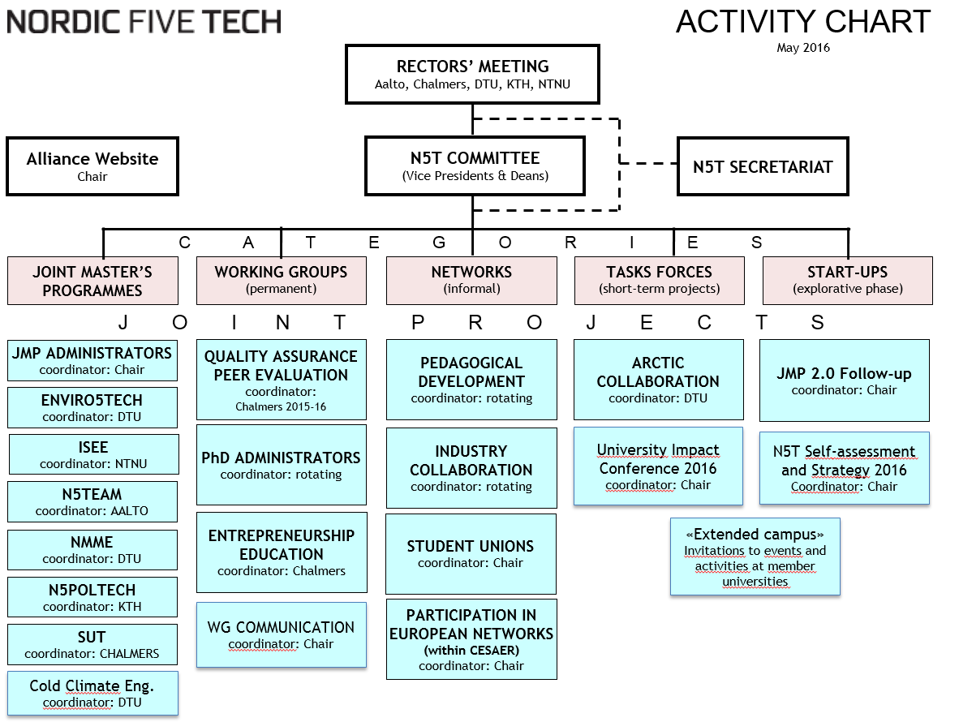

Annex 2 – Joint Master Programme Statistics

